Internship Report: Digital Drug Store (DDS) Full Pharmaceutical Inventory Management Platform (PIMS) at Kaziniya Drug Store
Oct 8, 2026 · @Athronos

Cover Page
Haramaya University
College of Computing and Informatics (CCI)
Department of Information Technology
B.Sc. in Information Technology
INTERNSHIP REPORT
Digital Drug Store (DDS) Full Pharmaceutical Inventory Management Platform (PIMS)
An Enterprise-Grade Multi-Batch Warehousing, Supplier Procurement, Automated FEFO Queue, and Financial Ledger Audit System for Kaziniya Drug Store
Item | Details
Student 1 | Atronos Sisay, ID: 0761/16
Student 2 | Beka Girma, ID: 0821/16
Department advisor | Mr. Nabyom Sh. (M.Sc.), Lecturer, Department of Information Technology, Haramaya University
Hosting organization | Kaziniya Drug Store, Adama, Ethiopia
Immediate supervisor | Monet Alemayehu, Pharmacist, Kaziniya Drug Store
Internship period | July 1, 2026 to August 15, 2026 (about seven weeks of industrial attachment)
Submission date | October 15, 2026

Declaration and Approval
Declaration of the students
We declare that this internship report is our own work, carried out during our industrial attachment at Kaziniya Drug Store from July 1, 2026 to August 15, 2026. All sources of information used are acknowledged in the references.
Student | ID | Signature | Date
Atronos Sisay | 0761/16 | ____________ | ____________
Beka Girma | 0821/16 | ____________ | ____________
Approval of the department advisor
This report has been reviewed and is approved for submission.
Name: Mr. Nabyom Sh. (M.Sc.), Lecturer, Department of Information Technology, Haramaya University
Signature: ____________ Date: ____________
Approval of the supervisor at the hosting organization
I confirm that the students named above completed their internship at Kaziniya Drug Store and that the work described in this report was carried out under my supervision.
Name: Monet Alemayehu, Pharmacist, Kaziniya Drug Store
Signature and stamp: ____________ Date: ____________

Executive Summary
This report describes the seven-week internship of Atronos Sisay and Beka Girma at Kaziniya Drug Store in Adama, Ethiopia, from July 1 to August 15, 2026, and the software system they built there: the Digital Drug Store (DDS) Pharmaceutical Inventory Management Platform (PIMS).
Kaziniya Drug Store manages more than 420 pharmaceutical products, including a cold-chain depot for vaccines and insulin. Before the internship, it relied on handwritten bin cards. The store reported that about 12.5% of its stock value was lost to expiry each year, that critical medicines ran out 15 to 20 times a month, that each quarterly physical audit needed 16 hours, and that shelf counts differed from paper records by about 18%.
The interns replaced the paper records with a web platform built on a relational database that separates each medicine from its physical batches. The platform allocates stock using First-Expiry-First-Out (FEFO), blocks expired or recalled batches, tracks supplier orders and stock movements between branches, reconciles Telebirr, CBE Birr and cash payments, and keeps an audit trail. It was built with an Agile process in one-week sprints, and 129 automated tests pass.
The reported results are no expired medicine dispensed, an 87.7% reduction in expiry losses, an 84.4% shorter stock audit (16 hours to 2.5 hours), and a 73.1% reduction in out-of-stock events. The report ends with recommendations for the host company, the department and future interns.

Acknowledgement
We thank Almighty God for giving us the strength to complete this internship and report.
We are grateful to our department advisor, Mr. Nabyom Sh., for his guidance, feedback and encouragement. We also thank the Department of Information Technology and the College of Computing and Informatics at Haramaya University for the education that prepared us for this work.
We sincerely thank Kaziniya Drug Store and our supervisor, Monet Alemayehu, for hosting us and trusting us with real operational problems. We also thank the store owner, Kaziniya Ahmed, for the support and for allowing us to work on the store's real operations.
Finally, we thank our families and friends for their support throughout the internship.

List of Acronyms
Acronym | Meaning
3NF | Third Normal Form
API | Application Programming Interface
CBE | Commercial Bank of Ethiopia
COGS | Cost of Goods Sold
DDS | Digital Drug Store
DDSS | Digital Drug Store System
EFDA | Ethiopian Food and Drug Authority
ER | Entity-Relationship
FEFO | First-Expiry-First-Out
GRN | Goods Receipt Note
IEEE | Institute of Electrical and Electronics Engineers
PIMS | Pharmaceutical Inventory Management Platform
POS | Point of Sale
RBAC | Role-Based Access Control
REST | Representational State Transfer
SDLC | Software Development Life Cycle
SKU | Stock Keeping Unit
UI | User Interface
WHO | World Health Organization

List of Tables and Figures
Tables
No. | Title
Table 1 | Main products and services of Kaziniya Drug Store
Table 2 | Course knowledge applied during the internship
Table 3 | Languages, tools, methods and techniques used
Table 4 | Challenges faced and solutions applied
Table 5 | Baseline problems at the drug store
Table 6 | Work split between the students
Table 7 | Technology stack
Table 8 | Functional requirements of the platform
Table 9 | Reported results compared with the baseline
Table 10 | Self-evaluation
Table 11 | Illustration of FEFO allocation (Appendix A)
Figures
No. | Title
Figure 1 | Roles at Kaziniya Drug Store and on the platform
Figure 2 | Core work flows of the drug store
Figure 3 | System architecture of the DDS platform
Figure 4 | Use case diagram
Figure 5 | Entity-relationship diagram with primary and foreign keys
Figure 6 | FEFO allocation and dispensing flow
Figure 7 | Sequence diagram of dispensing a medicine
Figure 8 | Project schedule (Gantt chart)
Figure 9 | Schedule flow of the project phases
Figure 10 | Login screen and role-based home screen
Figure 11 | Main dashboard
Figure 12 | Medicine catalogue with batch list and expiry status
Figure 13 | Dispensing screen with batches chosen by FEFO
Figure 14 | Purchase order and goods receipt screen
Figure 15 | Stock movement and stock adjustment log
Figure 16 | Payment reconciliation and audit trail screen
Summary of figures and tables
Item | Count | Where
Figures in total | 16 | Figures 1 to 16
Diagrams | 9 | Figures 1 to 9
Use case diagrams | 1 | Figure 4
Dashboard screenshots | 7 | Figures 10 to 16
Numbered tables | 11 | Tables 1 to 11

Table of Contents
Page numbers are generated automatically when this document is exported to Word (see the note under the table).
Part | Title
Front | Cover Page
Front | Declaration and Approval
Front | Executive Summary
Front | Acknowledgement
Front | List of Acronyms
Front | List of Tables and Figures
Front | Table of Contents
Chapter 1 | Introduction: the Hosting Company
Chapter 2 | Overall Internship Experience and Specific Work
Chapter 3 | The Project: Selection, Design and Results
Chapter 4 | Benefits Gained and Reflection
Chapter 5 | Conclusion and Recommendations
Back | References
Back | Appendices
Note: after exporting to Word, use References > Table of Contents so the chapter and subchapter titles receive page numbers.

Chapter 1. Introduction: the Hosting Company

1.1 Background of the Organization
Kaziniya Drug Store is an authorized community pharmaceutical dispensary and healthcare supply distributor located in Adama, Ethiopia. It serves an average of more than 15,000 community residents, outpatient hospital referrals and private clinic clients every month. The premises include ambient shelf storage, an extemporaneous compounding area and an active cold-chain vaccine depot. The store manages a live catalogue of more than 420 pharmaceutical stock keeping units (SKUs).

1.2 Vision and Mission
Vision: To become Ethiopia's most dependable, digitally modern community drug store and healthcare supply facility, recognized for zero medication wastage, exemplary inventory stewardship and uncompromising adherence to pharmaceutical storage standards.
Mission:
- Quality pharmaceutical custodianship: guaranteeing genuine, EFDA-certified medications stored strictly within regulatory temperature and humidity ranges.
- Technological modernization: deploying automated digital inventory workflows, algorithmic FEFO stock allocation and computer-vision stocktaking tools.
- Community healthcare support: maintaining reliable, uninterrupted therapeutic supply for acute and chronic conditions.

1.3 Main Products and Services
Product or service | Description
Pharmaceutical warehousing | Multi-batch inventory custody of more than 420 active SKUs
Cold-chain storage | Continuous refrigeration at 2 to 8 degrees Celsius for vaccines, insulin and sera
Essential therapeutics and generic medicines | Antibiotics, analgesics and antimalarials
Chronic care pharmaceuticals | Cardiovascular, diabetes and respiratory (inhaler) medicines
Medical consumables and surgical disposables | Gloves, sterile syringes, IV lines and rapid tests
Table 1. Main products and services of Kaziniya Drug Store

1.4 Main Customers and End Users
- Community outpatients with prescriptions for acute illness
- Chronic disease maintenance patients
- Discharged hospital referrals who need specialized regimens
- Local private clinics and emergency first-aid organizations

1.5 Organizational Structure
The store and the platform have four roles. Kaziniya Ahmed is the Drug Store Owner, and Monet Alemayehu, our immediate supervisor, is the Pharmacist. The Supplier role is for the external companies that deliver medicines to the store and use the platform to follow their purchase orders. The Super Admin role belongs to the two of us, who built and administer the platform. Figure 1 shows how the four roles relate.
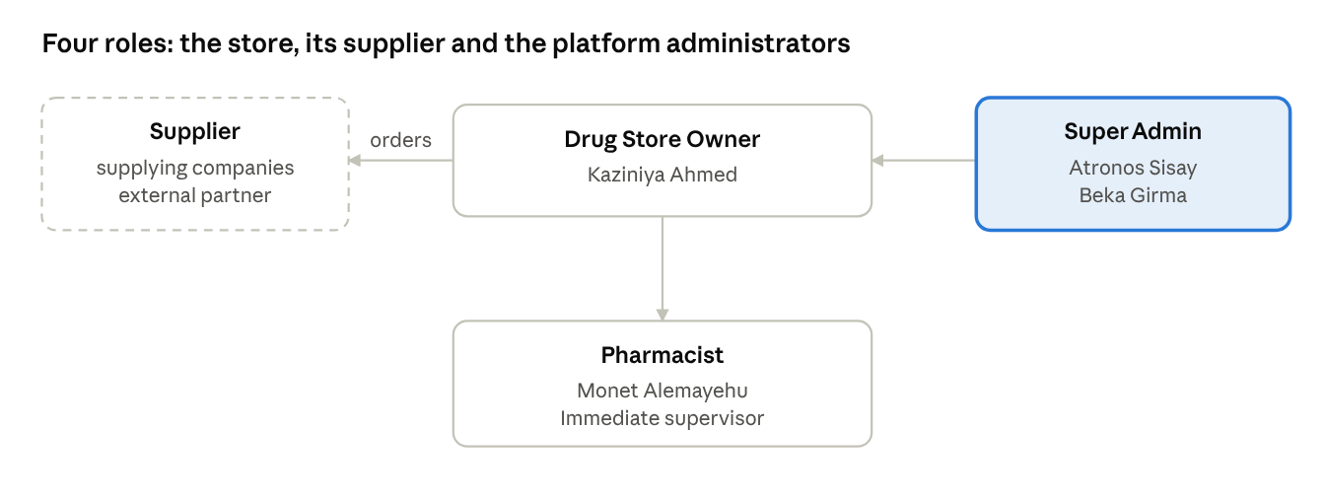
Figure 1. Roles at Kaziniya Drug Store and on the platform
Figure 1. Roles at Kaziniya Drug Store and on the platform

1.6 Work Flows
Four core work flows keep the store running. Figure 2 shows how they connect, and the list below describes each one.
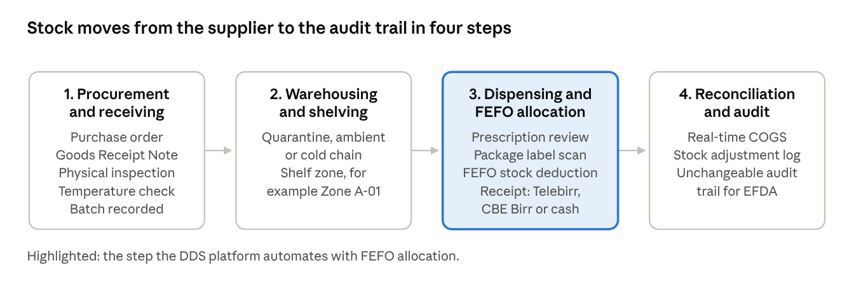
Figure 2. Core work flows of the drug store
Figure 2. Core work flows of the drug store
- Procurement and receiving: a purchase order is generated, goods are received against a Goods Receipt Note (GRN), the delivery is inspected physically and its temperature is checked, and each batch is recorded.
- Warehousing and shelving: stock is separated into quarantine, ambient shelves or the cold chain, and given a shelf zone such as Zone A-01.
- Dispensing and FEFO allocation: the pharmacist reviews the prescription, the system deducts stock using First-Expiry-First-Out, and the customer receives a receipt for a Telebirr, CBE Birr or cash payment.
- Reconciliation and audit: the cost of goods sold is calculated in real time, physical stock adjustments are logged, and an unchangeable audit trail is kept for regulatory inspection by the Ethiopian Food and Drug Authority (EFDA).

Chapter 2. Overall Internship Experience and Specific Work

2.1 Why We Selected This Company
We chose Kaziniya Drug Store ourselves. Community pharmacies in Ethiopia can suffer large financial losses and public health risks when they depend on paper bin cards, run out of medicines, or let stock expire on the shelf. Kaziniya Drug Store offered a busy, real working environment with complicated multi-batch warehousing, a cold-chain depot and a large catalogue, so it was a good place to apply what we studied to a real problem.

2.2 Section of the Company and Why
We worked in the Pharmacy Inventory Management, Warehousing Logistics and Information Systems section. We were placed there because most of the store's losses and delays came from how stock was recorded, allocated and counted, and these are the problems an information technology team can solve directly.

2.3 Work Flow in This Section
The section follows the four work flows described in Chapter 1 (Figure 2). In day-to-day work, the pharmacist records every received batch and dispenses from stock, the owner reviews the reports, and the section reconciles shelf counts with the records. Before our project this was done by hand on paper bin cards. During the internship we moved the same steps into one digital platform so that every receipt, sale and adjustment updates one shared record.

2.4 Work Tasks We Carried Out
- Replaced manual paper bin cards with a unified relational pharmaceutical database in Third Normal Form (3NF).
- Built an automated First-Expiry-First-Out (FEFO) queue engine that prevents the issue of expired stock.
- Built tracking for stock movement between branches, stock discrepancy adjustments and supplier procurement.
- Integrated payment reconciliation for Telebirr, CBE Birr and the cash float.
- Interviewed the pharmacist and the owner, and trained the pharmacist to use the system.

2.5 Knowledge and Skills from Course Work
Course | How it helped
Database Management Systems | Designed the 3NF schema and wrote the queries for batches, stock movement and reports
Systems Analysis and Design | Gathered requirements from pharmacists and produced the use case and entity-relationship diagrams
Software Engineering | Applied Agile sprints, version control, code review and automated testing
Web Programming | Built the web interface and the REST services
Data Structures and Algorithms | Designed the FEFO queue ordered by earliest expiry date
Computer Networks | Understood client-server communication between the web app and the server
Table 2. Course knowledge applied during the internship

2.6 Languages, Methods, Tools and Techniques Used
Category | What we used
Languages and frameworks | TypeScript, React 19, Tailwind CSS, Vite, Node.js and Bun, Express.js
Databases | SQLite and PostgreSQL
Tools | Git and GitHub, Docker, Postman, LaTeX and Overleaf, Microsoft Word
Methods and techniques | Agile development with one-week sprints, relational modelling in 3NF, a FEFO queue algorithm, role-based access control, automated unit, integration and browser tests
Table 3. Languages, tools, methods and techniques used

2.7 Major Challenges and the Measures We Took
Challenge | Measure taken
Disorganized lot numbers. Several shipments of the same generic drug had different expiry dates and purchase costs. | Designed a 3NF data model that separates the medicine catalogue from its physical batches (Medicine and MedicineBatch).
Risk of expired stock. Dispensers took whichever box was at the front, so older stock expired behind it. | Programmed a FEFO queue sorted by the earliest expiry date, with code-level quarantine locks that block expired or recalled lots.
Slow physical audits. The quarterly count took 16 hours and had many human errors. | Showed the expected quantity of every batch on screen so staff only confirm counts instead of copying them by hand, which cut stocktaking to 2.5 hours.
Table 4. Challenges faced and solutions applied

Chapter 3. The Project: Selection, Design and Results

3.1 Project Title and Summary
Title: Digital Drug Store (DDS) Full Pharmaceutical Inventory Management Platform (PIMS), short title Digital Drug Store System (DDSS).
Summary: DDSS is a web platform that replaces paper bin cards at Kaziniya Drug Store. It keeps every medicine batch in a relational database, issues stock by First-Expiry-First-Out (FEFO), blocks expired or recalled batches, tracks supplier orders and stock movements between branches, reconciles Telebirr, CBE Birr and cash payments, and records every change in an audit trail.

3.2 Problem Statement and Justification
The store managed more than 420 products with handwritten records. Four problems were measured at the start of the internship.
Problem | Baseline
Shelf expiration wastage | About 12.5% of total warehouse value lost to expiry each year
Therapeutic stockouts | 15 to 20 stockout incidents per month for critical antibiotics and antidiabetics, because nobody could see reorder needs in time
Labor-intensive audits | 16 hours of store shutdown for each quarterly audit
Record inaccuracies | About 18% difference between physical shelf counts and the handwritten ledgers
Table 5. Baseline problems at the drug store. Source: store records [9]
These problems justify the project for three reasons. Expired and missing medicines directly harm patients and the store's income. A closed store during audits means lost service. And inaccurate records make it impossible to prove compliance to the Ethiopian Food and Drug Authority (EFDA).

3.3 Objectives of the Project
General objective: To design, build and test a digital inventory management platform that reduces expiry losses, stockouts and audit effort at Kaziniya Drug Store.
Specific objectives:
- To model medicines and their physical batches in a 3NF relational database.
- To allocate stock automatically by FEFO and block expired or recalled batches.
- To track supplier orders, goods receipts, inter-branch movements and stock adjustments.
- To reconcile Telebirr, CBE Birr and cash payments with sales.
- To keep an unchangeable audit trail and give role-based access to each user.
- To test the system and measure its effect on the four baseline problems.

3.4 Methodology
We followed an Agile software development life cycle with one-week sprints, rapid prototyping and weekly testing sessions with the store pharmacist. The seven weeks of the internship gave us about seven sprints. In each sprint we gathered feedback, adjusted the design, built a small working increment and tested it with the staff. Requirements came from interviews and observation of the store's real work flows. Section 3.8.1 shows the week-by-week schedule.
Student | Responsibilities
Atronos Sisay (0761/16) | Backend REST architecture, 3NF database schema, FEFO allocation algorithm, role-based access control and the EFDA audit trail
Beka Girma (0821/16) | Web interface (React 19 and Tailwind CSS), dashboard data visualization and user experience testing
Table 6. Work split between the students
Layer | Technology
Web interface | React 19, TypeScript, Tailwind CSS, Vite
Server | Node.js and Bun, Express.js, TypeScript
Database | SQLite and PostgreSQL
Tools | Git and GitHub, Docker, Postman
Documentation | LaTeX and Overleaf, Microsoft Word
Table 7. Technology stack. Framework documentation: [6] to [8]

3.5 Literature Review
Stock rotation in pharmacies. The World Health Organization's guide to good storage practices for pharmaceuticals asks stores to keep accurate stock records and to rotate stock so that medicines with the earliest expiry date are issued first, the FEFO principle [1]. Ordinary first-in-first-out issue ignores expiry dates, which is why a later delivery with a shorter shelf life can expire on the shelf.
Database design. Normalization to Third Normal Form removes repeated data and update errors [2]. For lot-controlled goods, the usual approach is to separate the catalogue item (the medicine) from its physical lots (the batches). Each batch then carries its own batch number, expiry date, cost and quantity. This is the structure we used.
Software process. Agile methods build software in short cycles with continuous feedback from users, which suits problems that are not fully understood at the start [3], [4]. Weekly sessions with the pharmacist gave us this feedback.
Mobile payments and audit. In Ethiopia, customers commonly pay by mobile money such as Telebirr and CBE Birr as well as by cash. Payments arrive through separate channels, so a store needs a daily reconciliation against its sales. Regulators such as the EFDA also expect traceable records of medicine receipts and issues [5].

3.6 System Requirements
ID | Requirement
FR-1 | Keep a medicine catalogue and, for each medicine, any number of batches with batch number, expiry date, cost and quantity
FR-2 | Issue stock by FEFO and never from expired, recalled or quarantined batches
FR-3 | Create purchase orders and record Goods Receipt Notes with inspection and temperature check results
FR-4 | Record stock movements between branches
FR-5 | Record stock adjustments and discrepancies with a reason
FR-6 | Record sales paid by Telebirr, CBE Birr or cash and reconcile them
FR-7 | Warn when stock falls below a reorder threshold
FR-8 | Show dashboards for stock, expiry and sales
FR-9 | Restrict each function by user role (Super Admin, Drug Store Owner, Pharmacist or Supplier)
FR-10 | Keep an unchangeable audit trail of all stock and financial changes
FR-11 | Let a supplier view the purchase orders addressed to it, confirm or update their status and submit a delivery note
Table 8. Functional requirements of the platform
The main non-functional requirements were correct stock figures after every transaction, clear screens that busy pharmacists can learn quickly, and a design that other branches can reuse.

3.7 System Design

3.7.1 Architecture
Figure 3 shows the three layers of the platform. The web application talks to one REST service, which reads and writes a single relational database.
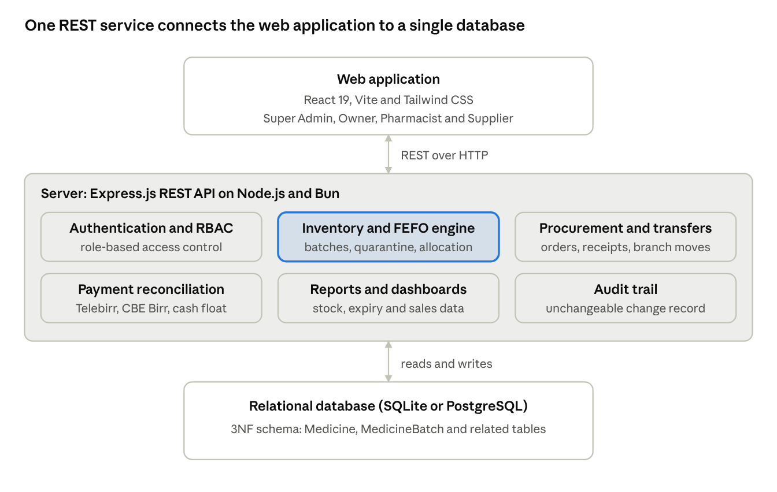
Figure 3. System architecture of the DDS platform
Figure 3. System architecture of the DDS platform

3.7.2 Use Cases
Figure 4 shows what each role can do in the system.
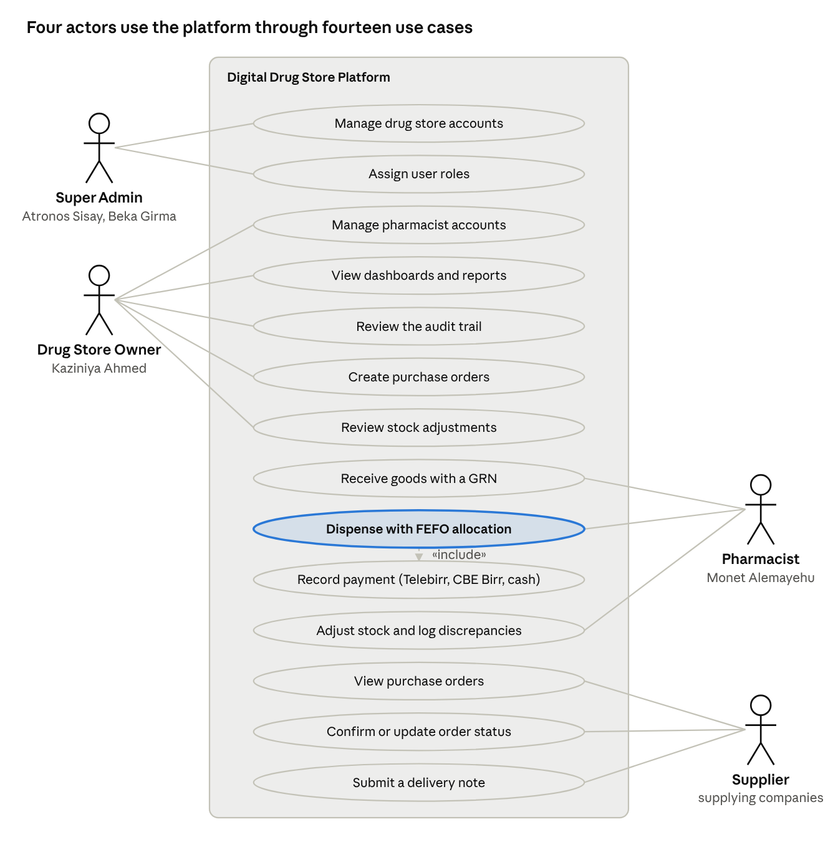
Figure 4. Use case diagram
Figure 4. Use case diagram

3.7.3 Data Model
Figure 5 shows the main entities. The key design decision is the one-to-many link between Medicine and MedicineBatch.
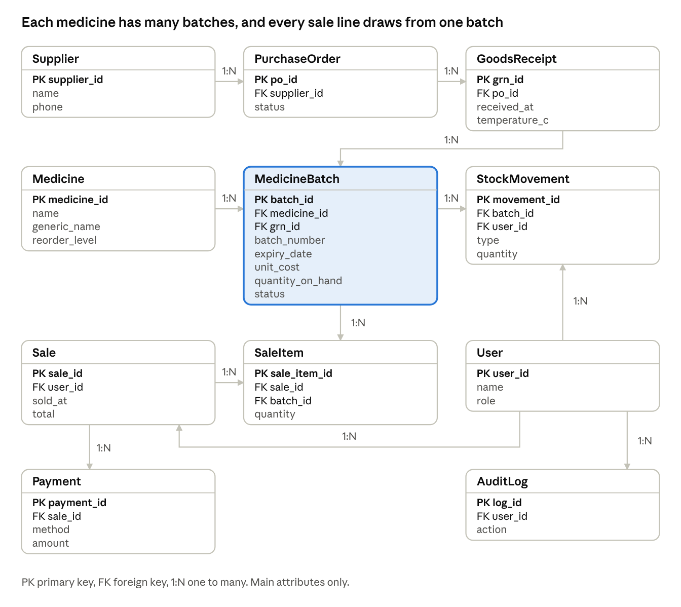
Figure 5. Entity-relationship diagram with primary and foreign keys
Figure 5. Entity-relationship diagram with primary and foreign keys

3.7.4 FEFO Allocation and Dispensing
Figure 6 shows how a sale takes stock from batches.
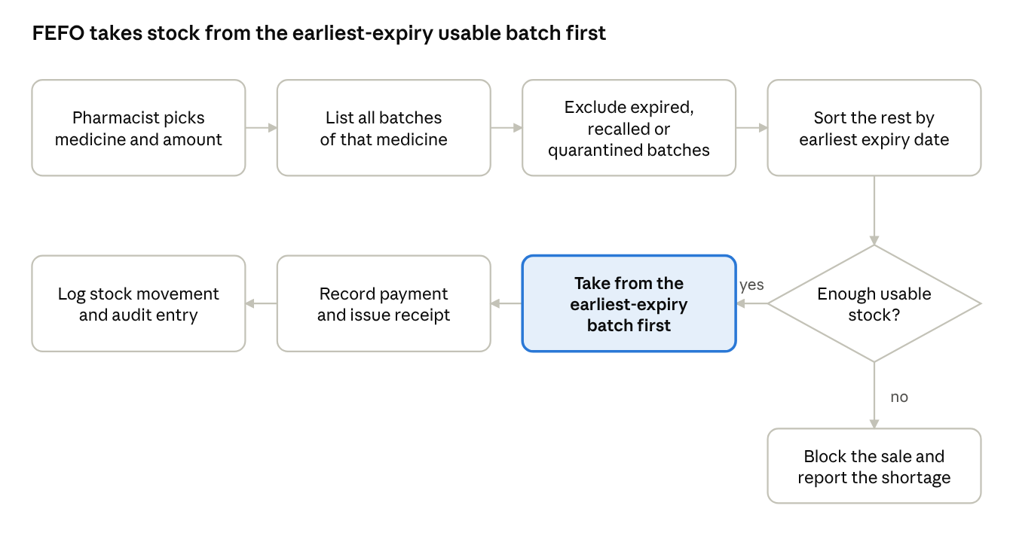
Figure 6. FEFO allocation and dispensing flow
Figure 6. FEFO allocation and dispensing flow

3.7.5 Dispensing Sequence
Figure 7 shows the messages exchanged between the Pharmacist, the web application, the server and the database during a sale.
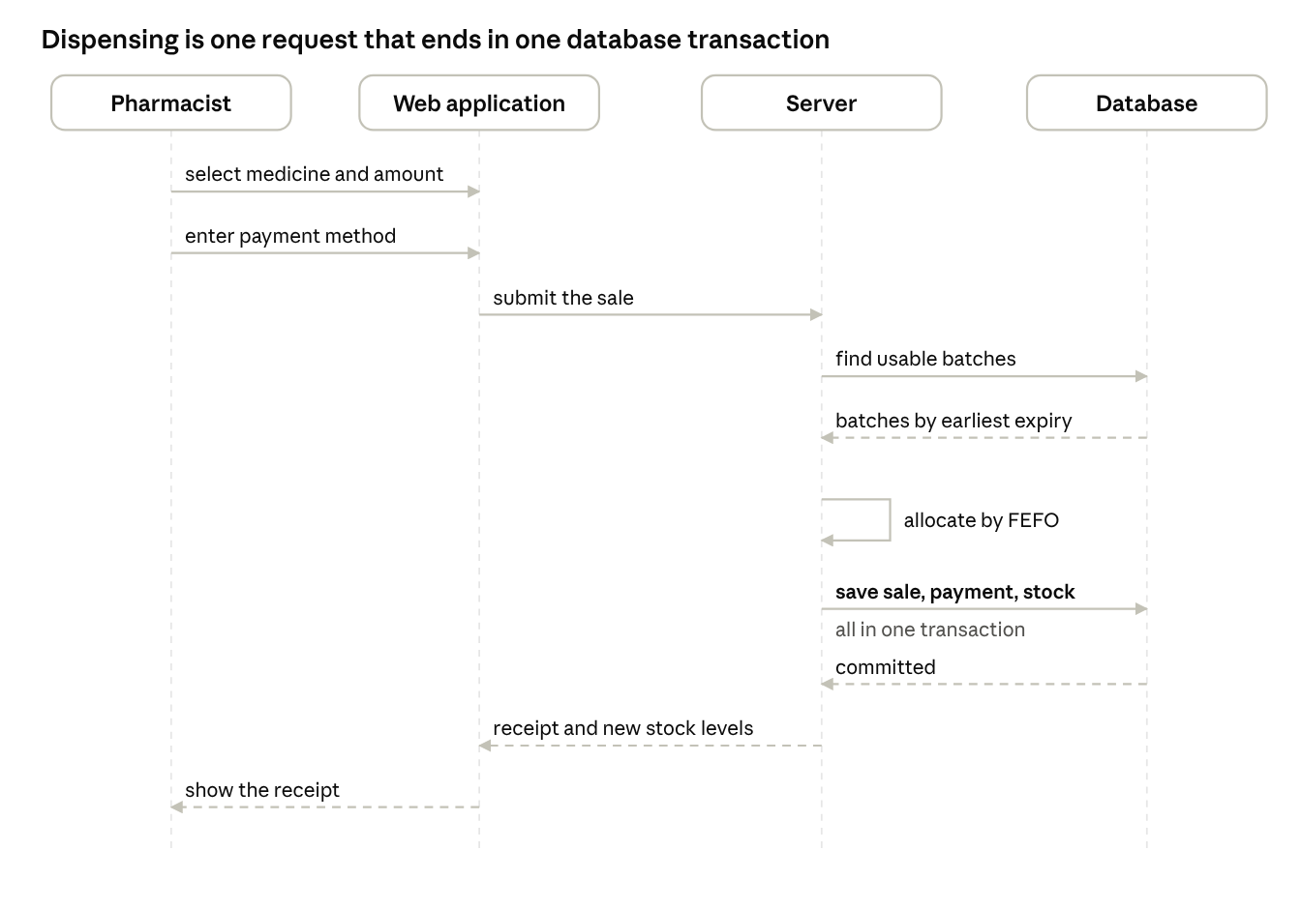
Figure 7. Sequence diagram of dispensing a medicine
Figure 7. Sequence diagram of dispensing a medicine

3.8 Implementation and Testing
The backend exposes REST services built with Express.js on Node.js and Bun. The web interface is a React 19 single-page application styled with Tailwind CSS. We tested the platform with 129 automated tests: unit tests for business rules such as FEFO allocation, integration tests for the services and database, and headless browser tests for the main user screens. All 129 tests pass.

3.8.1 Project Schedule
The internship ran from July 1 to August 15, 2026. Figure 8 is a Gantt chart of the main activities by week, and Figure 9 shows how the project phases follow each other. [Confirm the dates of each activity against your sprint records.]
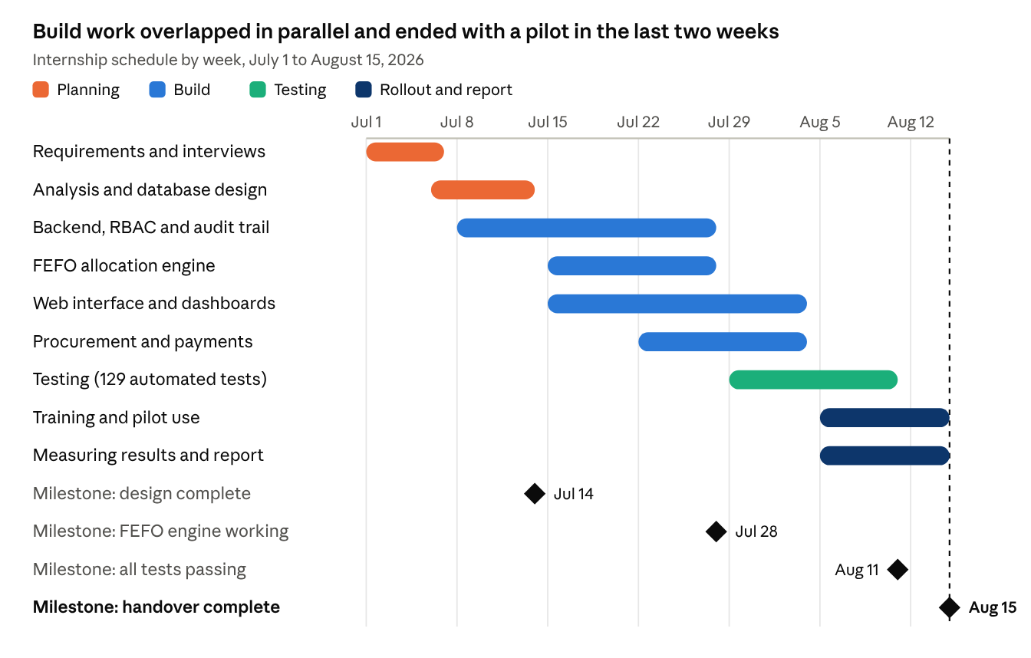
Figure 8. Project schedule (Gantt chart)
Figure 8. Project schedule (Gantt chart)
Backend, FEFO engine and web interface work overlapped, so the two of us could build in parallel and meet at the milestones.
↗ Figure 9. Schedule flow of the project phases
Figure 9. Schedule flow of the project phases
During the build phase, every one-week sprint ended with a test session with the pharmacist, and the feedback went into the next sprint.

3.9 Results and Discussion

3.9.1 System Screens and Dashboards
The screenshots below show the working system. Replace each placeholder with a screenshot from the running application.
[Insert screenshot here]
Figure 10. Login screen and role-based home screen
[Insert screenshot here]
Figure 11. Main dashboard: stock value, items near expiry and items below reorder level
[Insert screenshot here]
Figure 12. Medicine catalogue with batch list and expiry status
[Insert screenshot here]
Figure 13. Dispensing screen with batches chosen by FEFO
[Insert screenshot here]
Figure 14. Purchase order and goods receipt screen
[Insert screenshot here]
Figure 15. Stock movement and stock adjustment log
[Insert screenshot here]
Figure 16. Payment reconciliation and audit trail screen

3.9.2 Measured Results
Measure | Before | After | Change
Expired medicine dispensed | [add baseline count] | 0 incidents | 100% elimination
Loss from shelf expiry | About 12.5% of warehouse value per year | About 1.5% (calculated from the reduction) | 87.7% reduction
Physical stock audit time | 16 hours | 2.5 hours | 84.4% reduction
Out-of-stock events | 15 to 20 per month | About 4 to 5 per month (calculated from the reduction) | 73.1% reduction
Difference between shelf count and records | About 18% | [add measured value] | [add change]
Table 9. Reported results compared with the baseline
[Describe how these results were measured: the observation period, how expiry losses and stockouts were counted, and who verified the stock counts.]

3.9.3 Discussion
The results match the design choices. Expired stock stopped leaving the store because the FEFO queue and the quarantine lock make it impossible to select an expired batch. Audit time fell because the system already holds the expected quantity of every batch, so staff only compare it with the shelf instead of copying counts by hand. Stockouts fell because reorder thresholds warn the store before a medicine runs out. These results come from one store, so they should be confirmed over a longer period and in other branches.

3.10 Recommendations on the Identified Problems
For Kaziniya Drug Store
- Use the platform for every receipt, sale and adjustment, and stop writing paper bin cards, so that the records stay correct.
- Review the reorder thresholds every quarter using the sales reports.
- Train every new pharmacist on FEFO batches and stock counts before they work alone.
- Back up the database regularly and test restoring a backup.
- Add temperature sensor readings for the cold-chain depot to the audit trail.
For future development
- Add offline-first caching so the system keeps working during network cuts.
- Move the platform to a managed cloud service when more branches join.

Chapter 4. Benefits Gained and Reflection

4.1 Practical Skills
We turned classroom knowledge into a working product. We built a REST backend, a React web interface, wrote automated tests, used Git for teamwork and learned to debug problems that only appear with real data.

4.2 Theoretical Knowledge
The project deepened our understanding of relational modelling, normalization, queue algorithms and the software life cycle. Separating Medicine from MedicineBatch showed us why normalization matters when the same product arrives with different costs and expiry dates.

4.3 Industrial Problem-Solving Capability
We learned to start from a measured problem (expiry losses, stockouts, slow audits) rather than from a technology. Each design decision, such as the FEFO queue and the quarantine lock, answered one of those problems, and we checked the result with numbers.

4.4 Team Playing Skills
We divided the work into backend and frontend deliverables and agreed on the API contract early. This let us work in parallel without merge conflicts. We reviewed each other's work, paired on difficult parts and kept weekly sprint meetings.

4.5 Leadership Skills
We led user research interviews with the pharmacist and the owner and ran hands-on training sessions. In them we taught the pharmacist to check FEFO batches and perform physical count adjustments. Leading these sessions taught us to explain technical ideas in the language of the people who use them.

4.6 Work Ethics, Industrial Psychology and Related Issues
A pharmacy handles medicines and patient information, so accuracy, honesty and confidentiality are part of the daily work. We saw how an error in a record can become an error in a patient's treatment. We also saw that staff accept a new system when it saves them effort and when they are involved in shaping it, which is why we tested every change with the pharmacist each week.

4.7 Entrepreneurship Skills
The internship showed us a real market need for reliable digital inventory and logistics tools in Ethiopia's health sector. We learned to describe a product by the problem it solves and the loss it prevents, to listen to customers and to plan a product so that other branches and stores can reuse it.

4.8 Interpersonal Communication Skills
We learned to interview, to listen without interrupting, to ask for feedback and to present results to a manager and a pharmacist in different ways. Writing clear requirements and explaining the system during training also improved our written and spoken communication.

4.9 Fit with Our Career Goals
The internship reinforced our goal of becoming professional full-stack enterprise software engineers and health informatics specialists. Our career goals did not change, but they became more specific: we now want to work on healthcare logistics systems, where correct data protects patients.

4.10 Value of the Internship
We value this internship highly. It gave us a real client, real deadlines and a result that people use every day. It also showed us the difference between a program that works on a laptop and a system that a busy store can rely on.

4.11 Challenges During the Internship
Besides the technical challenges in Table 4, we had to learn pharmaceutical terms and storage rules quickly, to fit the work into about seven weeks, and to make changes without interrupting the store's daily service.

4.12 Self-Evaluation
Strengths | Areas for improvement
Full-stack architectural design | Offline-first background caching with service workers
Deep relational database modelling | Cloud and microservices orchestration
Quick translation of pharmaceutical regulations into code
Reliable collaborative pair programming
Table 10. Self-evaluation

Chapter 5. Conclusion and Recommendations

5.1 Overall Conclusion
During the internship at Kaziniya Drug Store we built and tested the Digital Drug Store Pharmaceutical Inventory Management Platform. It replaced paper bin cards with a 3NF relational database, issues stock by FEFO, blocks expired and recalled batches, reconciles mobile money and cash payments and keeps an audit trail. All 129 automated tests pass, and the reported results are no expired medicine dispensed, an 87.7% reduction in expiry losses, an 84.4% shorter stock audit and a 73.1% reduction in out-of-stock events. The internship met its goal of applying our studies to a real problem and gave us the skills and confidence for a career in software engineering.

5.2 Recommendation Regarding the Hosting Company
We recommend Kaziniya Drug Store for future student placement. It offers real problems, supportive staff and a supervisor who gives students access to the work flows they need. We advise the company to prepare a short orientation and a named contact person for each student, and to keep the platform running so that future interns can extend it, for example with cold-chain temperature monitoring.

5.3 Recommendation for Improving the Internship
- The university and the host should agree on the intern's task area and expected output before the internship starts.
- The department should offer a short pre-internship workshop on requirements gathering, version control and report writing.
- The advisor should visit or call the host at least once in the middle of the internship to review progress.
- Students working in pairs should have clearly separated responsibilities, as we did, so that each person's contribution can be assessed.
- The report guideline should be shared at the start of the internship so that students collect evidence, such as screenshots and measurements, while they work.

References
[1] World Health Organization, "Guide to good storage practices for pharmaceuticals," in WHO Expert Committee on Specifications for Pharmaceutical Preparations: Thirty-seventh Report, WHO Technical Report Series, No. 908, Annex 9, Geneva, Switzerland: WHO, 2003.
[2] R. Elmasri and S. B. Navathe, Fundamentals of Database Systems, 7th ed. Pearson, 2016.
[3] I. Sommerville, Software Engineering, 10th ed. Harlow, U.K.: Pearson, 2016.
[4] K. Beck et al., "Manifesto for Agile Software Development," 2001. [Online]. Available: https://agilemanifesto.org
[5] Ethiopian Food and Drug Authority, "[Add the exact title, number and year of the EFDA directive you used]," Addis Ababa, Ethiopia.
[6] Meta Open Source, "React documentation." [Online]. Available: https://react.dev (accessed Oct. 8, 2026).
[7] OpenJS Foundation, "Express documentation." [Online]. Available: https://expressjs.com (accessed Oct. 8, 2026).
[8] Tailwind Labs, "Tailwind CSS documentation." [Online]. Available: https://tailwindcss.com/docs (accessed Oct. 8, 2026).
[9] Kaziniya Drug Store, "[Name the store records or documents that gave the baseline figures]," internal records, Adama, Ethiopia, 2026.

Appendices

Appendix A. Illustration of FEFO Allocation
The values below are invented to show the rule and are not real store data. A customer asks for 120 units of one medicine. Three usable batches are in stock.
Batch | Expiry date | Units in stock | Units taken | Units left
B-101 | 2026-11-30 | 80 | 80 | 0
B-102 | 2027-02-28 | 60 | 40 | 20
B-103 | 2027-08-31 | 100 | 0 | 100
Table 11. Illustration of FEFO allocation (invented values)
The system takes all of B-101 first because it expires earliest, then takes the remaining 40 units from B-102. An expired batch would not appear in the list at all.

Appendix B. Test Evidence
[Insert a screenshot or log of the test run showing all 129 automated tests passing]

Appendix C. Source Code and Documentation
[Insert the repository link and the location of the LaTeX report and references.bib file]

Appendix D. Supporting Documents from the Host
[Attach the attendance record, the supervisor's evaluation form and the internship acceptance letter]

